Class Test:1

Course: Theory of Computation Mark:

1.Describe DFA with appropriate example? Also Explain 5 tuples of DFA?

2. Describe the difference between DFA and NFA?

3. Define transition diagram with appropriate example?

4. Construct a DFA with ∑ = {0, 1} accepts all strings starting with 1 and ending with 0.

5.

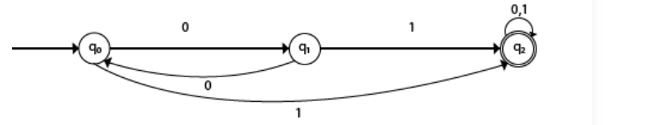

Is it DFA OR NFA? Then construct the transition diagram?

Class Test:1

Course: Theory of Computation Mark:

1.Describe DFA with appropriate example? Also Explain 5 tuples of DFA?

2. Describe the difference between DFA and NFA?

3. Define transition diagram with appropriate example?

4. Construct a DFA with ∑ = {0, 1} accepts all strings starting with 1 and ending with 0.

5.



Is it DFA OR NFA? Then construct the transition diagram?